## logo new with r

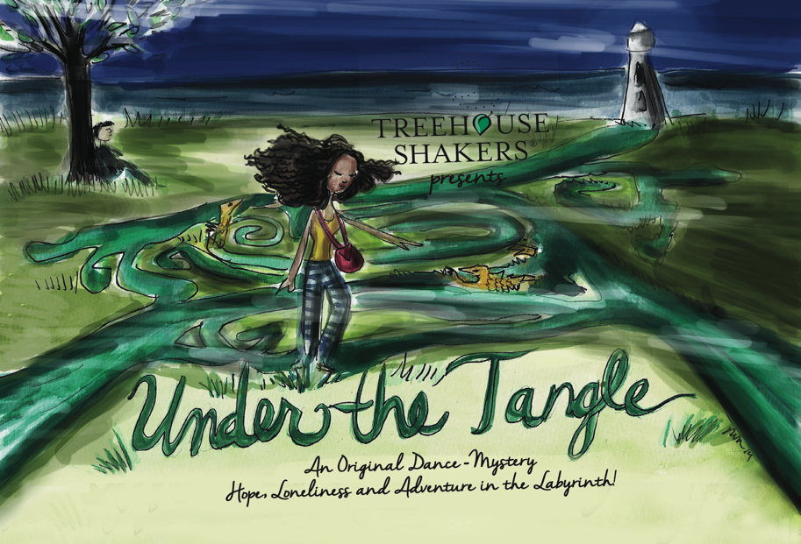

(Artwork by Rebecca Miller)

**UNDER THE TANGLE**

**Conceived and Choreographed by Emily Bunning**

**Costumes by Patti Gilstrap**

**Set by Ioannis Sochorakis**

**Lighting by Dan Ozminkowski**

**Original Sound Score by Martyn Axe**

**Created in Collaboration with the Performers: Ashley Chavonne, Ashley Ervin, Trey Mitchell, Katie Montoya, and Miranda Wilson**

**For Ages 8 +**

**Running Time: 50 minutes**

Visually Vibrant, **Under the Tangle**, is the dance-mystery about an adolescent girl who becomes ensnarled in an intriguing labyrinth after the sudden loss of her parents. Throughout her journey, she twists along the maze being confronted with obstacles, finding numerous clues revealing life lessons and meeting many unusual characters: a flock of birds, the daunting labyrinth guards, and the Queen of the Lost perched upon a grim tower. As a metaphor for adolescence, this visual and artistic adventure exposes emotions of loneliness, otherness, hope, and accomplishment. It is this journey of obstacles, relationships, and discoveries, which strengthen the young girl’s character, and eventually set her free from the labyrinth.

**STUDY GUIDE**

**SYNOPSIS:**

***Please do not share the synopsis with your students before the performance. The synopsis should only be used as a framework for a discussion after the performance.***

**Under the Tangle** is the vibrant dance-mystery about an adolescent girl ensnarled in a labyrinth looking for answers after the death of her parents sets her off on an adventure.

The show begins with a short introduction to the family and then a fire heard in the distance. The parents are pulled away from the girl, but before they go, they share a movement message with her, yet she does not quite understand what they are trying to communicate. Her loss and sadness sends her running until she arrives in an unknown land with a mysterious labyrinth. After drifting off to sleep, she meets a young half bird-boy and together they decide to enter the labyrinth in search of her parents’ clue. Along her journey she becomes ensnarled by the labyrinth, has to fight off two labyrinth guards with her movement, is scared by and then befriended by a flock of black birds and finally reaches the water which is the clue her parents where telling her about. Along the way, she learns perspective, friendship, stillness and the power of aloneness. Also, part of the maze is a non-sensical map of characters that seem confusing at first, but eventually lead the way through the labyrinth.

After being relieved to find the water, yet still not quite sure what it means, the girl notices a towering lighthouse with the Queen of the Lost perched on top. The Queen of the Lost becomes a powerful reminder of her mom, who has been with the young girl the entire journey. She bids farewell to the boy and attempts to scale the tower, meeting more challenges, until she is face to face with the mysterious Queen. Ultimately, the Queen was teaching her life lessons as she traveled through the labyrinth to prepare her

for her real journey out to sea. Her parent’s lost boat is waiting to take her towards her future life.

**Under the Tangle** is a visual journey for the audience. We want them to be engrossed in the dance, a champion for the main character, and to be intrigued with the unusual characters she meets along her journey. There are many lessons to be learned.

*“In today's information age, where we can look up an answer on the Internet and have it immediately, there isn’t any room for the new generation to practice living in the unknown. UNDER THE TANGLE is a beautifully expressed and novel artistic gift for the students. By watching and seeing visual dance patterns slowly reveal a moving story, they had the very unusual experience of trusting exactly where they are and what they know to get them to the end of the story where everything came together effortlessly.”*

*-*Rashmi Singh, Audience Member, Private Language Teacher

**CURRICULUM CONNECTORS**

1. **Arts Appreciation**
   1. Making Connections

By investigating historical, social and cultural contexts, and by exploring

common themes and principles connecting dance with other disciplines,

students enrich their creative work and understand the significance of

dance in the evolution of human thought and expression.

* 1. Responding to and Analyzing Works of Art

Students will respond critically to works in the arts, connecting the individual work to other works and to other aspects of human endeavor and thought.

1. **Social Studies**
   1. Connecting Self with family, community, and environment
   2. Emotional Journey of the character. By watching a performance, students are given an opportunity to see difficult subjects: death, loneliness, and otherness and then can process these feelings with the characters onstage. Teaching empathy, solace, solutions, and empathy through kinesthetic connections.
2. **Greek Mythology**  
    a. Connecting Greek Mythology; using the infamous story of *Theseus and*

*the Minotaur* as a guide. Discover and study Theseus, one of the greatest heroes, and the Minotaur, one of the most terrifying monsters within Greek Mythology. This is also a powerful story of place and ancient history, which delves into the two of the main city–states in the Hellenic world: Athens and Crete. This is also the story that Daedelus’ labyrinth is revealed to house the terrifying Minotaur. Study these places, their histories, the rulers, and discuss their differences.

b. In *Under the Tangle* our heroine follows her own journey, which doesn’t involve a terrifying Minotaur; but does have some comparable themes to the aforementioned Myth. Encourage students to draw or write the heroine’s journey while contemplating the thematic references to the story of *Theseus and the Minotaur*.

1. **Elements of Nature**
   1. Fire, Wind, Earth, and Water are all represented in the piece. They are the fundamental powers of nature and are considered the simplest principals for which everything is a based. Many ancient cultures used the elements as a guide for healing and balancing life.

## BEFORE SEEING THE PERFORMANCE

1. **Explore Labyrinths and Their Meaning**A labyrinth is a single path or a unicursal tool for personal, psychological and spiritual transformation. Labyrinths are thought to enhance right brain activity. <http://www.labyrinthsociety.org>

In colloquial English, *labyrinth* is generally synonymous with [*maze*](http://en.wikipedia.org/wiki/Maze), but many contemporary scholars observe a distinction between the two: *maze* refers to a complex branching (multicursal) puzzle with choices of path and direction; while a single-path (unicursal) *labyrinth* has only a single, non-branching path, which leads to the center. A labyrinth in this sense has an unambiguous route to the center and back and is not designed to be difficult to navigate. We use them synonymously in the performance.

<http://en.wikipedia.org/wiki/Labyrinth>

1. Read or Tell the Greek Story of the Minotaur. In [Greek mythology](http://en.wikipedia.org/wiki/Greek_mythology), the **Labyrinth** was an elaborate structure designed and built by the legendary architect [Daedalus](http://en.wikipedia.org/wiki/Daedalus) for King [Minos](http://en.wikipedia.org/wiki/Minos) of [Crete](http://en.wikipedia.org/wiki/Crete) at [Knossos](http://en.wikipedia.org/wiki/Knossos). Its function was to hold the [Minotaur](http://en.wikipedia.org/wiki/Minotaur), a mythical creature that was half man and half [bull](http://en.wikipedia.org/wiki/Bull_(mythology)) and was eventually killed by the [Athenian](http://en.wikipedia.org/wiki/Athenian) [hero](http://en.wikipedia.org/wiki/Hero) [Theseus](http://en.wikipedia.org/wiki/Theseus). Theseus was aided by [Ariadne](http://en.wikipedia.org/wiki/Ariadne), who provided him with a skein of thread, literally the "clew" or "clue", so he could find his way out again.

In **Under the Tangle** the girl is guided and challenged by the three labyrinth dancers who use long sleeves, the set panels, and movement to provide clues as to the way out of the labyrinth. The boy is half-boy, half bird giving him mythical characteristic that leads to his disappearance.

1. **Under the Tangle** uses modern dance as a way for the body to express ideas, emotions, and story. Introduce Modern Dance to your students. Modern dance is the combination and freedom of creativity/inventiveness, rhythm (reoccurring sound or action), and movement, including energy, shape, space, and locomotion. It is often practiced with bare feet so the dancer has a full range of foot movement and can be grounded to the floor.   
     
   Learn the History of Modern Dance. Modern Dance began in the early 1900’s as a rebellion to the strict rules of ballet. Discuss or watch modern dance. You could watch famous Modern dancers: Isadora Duncan, Martha Graham, Doris Humphrey, Twyla Tharp, Alvin Ailey, and Merce Cunningham. Discuss other forms of dance including: ballet, jazz, tap, hip-hop, social dance, and clogging.

*The labyrinth of loneliness is a universal experience, in one form or other, for all young people.  In 'Under the Tangle,' the turmoil of being lost and alone is enacted kinesthetically before the audience's eyes; it is grappled with, danced through, and eventually overcome.  Loneliness is no longer a frightening frontier; instead, through the arc of this tale, it becomes an archetypal journey filled with creative potential.  In this poignant dance-play, we watch as the heroine moves from being lost and 'tangled' into a realm in which she learns to fashion her own path, construct new worlds, and realize, gradually, an authentic and empowered sense of Self.  The audience benefits vicariously; we recognize ourselves in this odyssey, and know that we, too, may be stuck for a time in the mud and mire of Loneliness's stoic grip.  Children, in particular, know this affective domain of unwanted isolation only too well.  Like the best of children's literature, 'Under the Tangle' depicts beautifully how a young adventurer is capable of mapping out his or her own inventive routes (and roots!) through the darkest of emotional underworlds.  The body, voice, and imagination are valuable tools and compasses.  By employing these instruments alone - and eventually with others - a road to a higher, more creative ground is achieved one step and leap at a time.*

    --- Julia M. Morris, Ph.D.

       Author, "Childhood Loneliness: The Creative Construction of Self and World Inside Story and Beyond" (dissertation, Pacifica Graduate Institute, 2014)

## AFTER SEEING THE PERFORMANCE

1. After seeing **Under the Tangle** discuss the performance with your class.   
   Some Themes for Classroom Discussion within **Under the Tangle**:

**Lonliness  
Lonliness** is a strong theme within the piece. How was lonliness explored during **Under the Tangle**?

Lonliness often plays a central role within children’s literature, world folklore and oral storytelling, especially when children are the main characters. From time to time all children feel a sense of being the outcast, not belonging, or a sense of aloneness.

What are some of the themes of lonliness that are revealed within **Under the Tangle?**

Are there times in your own life you have felt similarly?

**Abandonment**.

Many times, central characters in children’s literature have been orphaned or abandoned by their parents. Are there other literary stories, other than **Under the Tangle,** that you can name that have this theme?  
  
There are many books and stories that are rich with literature that have an orphaned child character as the main character, who goes onto explore a fantasyland. What are some books or stories you have read that reflect on this? Here are a few of Treehouse Shakers’ favorites and recommendations.

**Harry Potter** **Series** by J.K. Rowling

**The Bad Beginning** by Lemony Snickett

**Alice in Wonderland** by Lewis Carrol

**The Secret Garden** by Frances Hodgson Burnett

**The Chronicles of Narnia** by C.S. Lewis  
**James and the Giant Peach** by Roald Dahl

**Blackhope Enigma** by Teresa Flavin

**The Forest in the Hallway** by Gordon Smith

**The Phantom Tollbooth** by Norton Juster

**The Little Prince** by Antoine de Saint-Exupery  
  
**Stillness**  
Stillness can often times help us find clarity to a problem. Are there ways within the piece that the themes of stillness were exposed?

Labyrinths are often used as a place of meditation. Discuss how meditation can be a useful way to understand a problem.

**Perspective**

What is the meaning of perspective? Does the main character find different perspectives that help her untangle her path?

How was dance used to tell the story of **Under the Tangle**? Did the students understand how the labyrinth was portrayed in the piece?

## ACTIVITES:

1. Stories can be told through words, theater, music, and art. The ideas are endless. **Under the Tangle** was told primarily through modern dance. Have the students work together as choreographers to make a short piece (it can have a storyline or not.) Then have your students share their choreography with the other groups.

**Terminology for Dance:**

**Choreographer** is the person who makes dances.

**Choreography** is use of shape, space, locomotion, rhythm and dynamics to create dance.

Divide into groups with 4 students each. Each student then chooses a shape with their body, a path in space, and a way to travel on that path. Then the students share their material and discuss how to put it all together. They may decide to learn each of the dances and dance it together in a sequence, or do one at a time, or do a combination of both. Another possibility; everyone travels center from the sides with their own movement and then combine their individual movements.

1. Have the students draw an intricate pattern. Then have them walk it in the room. Next have students create a character that walks the pattern, at the end has a transformation and then use that affect on the character to walk back through the pattern.
2. Write a “shape poem” or “drawing poem” using a maze or labyrinth. Can also create a dance to express these poems.
3. Share these labyrinth puzzles (below) with your students.

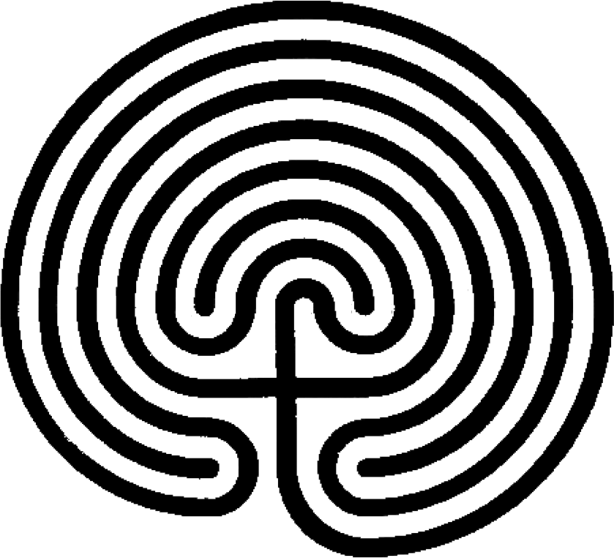

Original drawing by Jeff Saward, final graphic by Vicki Keiser.

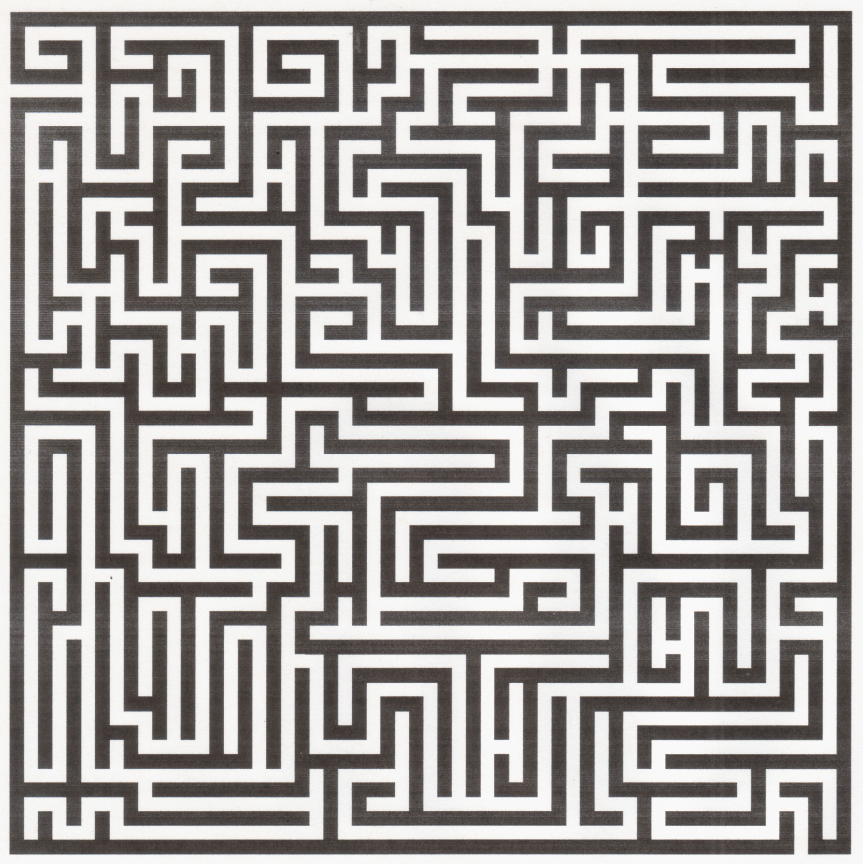

**About Treehouse Shakers**

Treehouse Shakers, Inc., a non-profit dance and theater company, was co-founded in 1997 by collaborators and childhood friends, Emily Bunning, choreographer/dancer, and Mara McEwin, writer/actor. Treehouse Shakers has created and performed thirteen original dance-plays for young audiences and adults in many established performance venues, including theaters, festivals and schools across the nation. Treehouse Shakers creates work that experiments with narrative styles and explores the story's elements through the abstractions of modern dance. With each new piece, we challenge ourselves as artists to not only create the highest caliber of work, but also to create work that will stimulate, connect and entertain our audience members. Our young audience programming is unique in its offering young audiences a guided look at modern dance through powerful and meaningful theater. Our work is sometimes the first performance, specifically in viewing dance, which many young people experience. We want to sharpen their aesthetics as they are entertained, challenged, and engaged, while at the same time expanding their knowledge of various art forms. We have built our repertory to carefully address every age level within youth programming, and can proudly say we serve babies to teens. We are building audiences who are creative-thinkers and hopefully life-long performance enthusiasts.

Currently, Treehouse Shakers has six original performances for young audiences on a rotating tour across the nation as well as an annual New York City Season. Our touring repertoire includes; **Animal Rhythms, Desert Travels, Coyote’s Dance, Hatched**, **Let’s Talk About IT!**, and **Under The Tangle**. **Animal Rhythms** introduces audiences to rhythm, modern dance and theater through the power and culture of West African folklore. **Desert Travels** gives young audiences a mesmerizing taste of life in the Middle East by portraying the sights, sounds and stories of the culture. **Coyote’s Dance** follows Coyote, who is both clown and teacher, on a humorous journey of deceit and adventure. **Hatched** for babies, toddlers and preschoolers, is performed through movement, handcrafted puppets, and very little human dialogue. Set amidst an American family farm, young audience members are encouraged and narrated to interact and play with the characters onstage; they give the chicks their feed, milk bottles to the lamb, and worms to the baby birds. It is a beautiful and delicate tale, told through exquisite visuals, live music, and the exploration of newborn animals. We want this experience to begin their relationship to the dance, helping to build future audience members, as well as lovers of imagination and artistic expression. Treehouse Shakers is currently the only American company which has an extensively touring “baby drama” **Hatched**, that allows for a guided look at movement for the youngest of audiences. **Let’s Talk About IT!** is a coming of age dance-play for teens that deftly and humorously explores peer pressure, bullying, relationships, and the challenges teens face in the twists of every day.

Our newest piece, **Under the Tangle**, is the dance-mystery about an adolescent girl who becomes ensnarled in an intriguing labyrinth after the sudden loss of her parents. Throughout her journey, she twists along the maze being confronted with obstacles, finding numerous clues revealing life lessons and meeting many unusual characters: a flock of black birds, the daunting labyrinth guards, and the Queen of the Lost perched upon a grim tower. It is this journey of obstacles, relationships, and discoveries, which strengthen the young girl’s character, and eventually set her free from the labyrinth.

Treehouse Shakers’ young audiencework has been praised by Laurel Graeber in the *New York Times*, and featured in *New York Magazine, Time Out Kids, New York 1’s Parenting Report, CBS-TV’s Morning Show, Mommy Poppins, Village Voice*, *New York Post*, and *The Daily News,* among others. Our young audience work has received funding from the New York City’s Department of Cultural Affairs, New York State Council on the Arts, Edith Lutyens and Norman Bel Geddes Fund, Lower Manhattan Cultural Community’s Fund for Creative Communities and Manhattan Community Arts Fund, The Nancy Quinn Fund, Puffin Foundation, Ltd., Meet the Composers, BOCES, Rosenthal Family Foundation and the Wyoming Arts Council. Some highlighted performance venues for all of our dance-plays include: *United Nations (NYC), The Peter Jay Sharp Theater (NYC), The Ailey Citigroup Theater (NYC), Manhattan Movement and Arts Center (NYC), Victoria Theater Associations (Dayton, OH), Alden Theater (McLean, VA), Aronoff Center (Cincinnati, OH), Paramount Theater (Peekskill, NY), Westhampton Beach Playhouse (L.I., NY), Tribeca Film Festival (NYC),* and *Jacob’s Pillow's Community Day (Becket, MA) Two Rivers Theater (Red Bank, NJ), Black Rock Theater (Germantown, MD), Bucks County Playhouse (New Hope, PA).*

**We would love to hear from you! Send us your thoughts, drawings or writings from Under the Tangle. We will to post on our website and blog.**

**Thank you!**

Treehouse Shakers

PO Box 186

Radio City Station

New York, NY 10101

[www.treehouseshakers.com](http://www.treehouseshakers.com)

contactus@treehouseshakers.com

212.715.1914

#### This study guide was created by the Treehouse Shakers, Inc. © 2015