Hatched
Life on The Farm

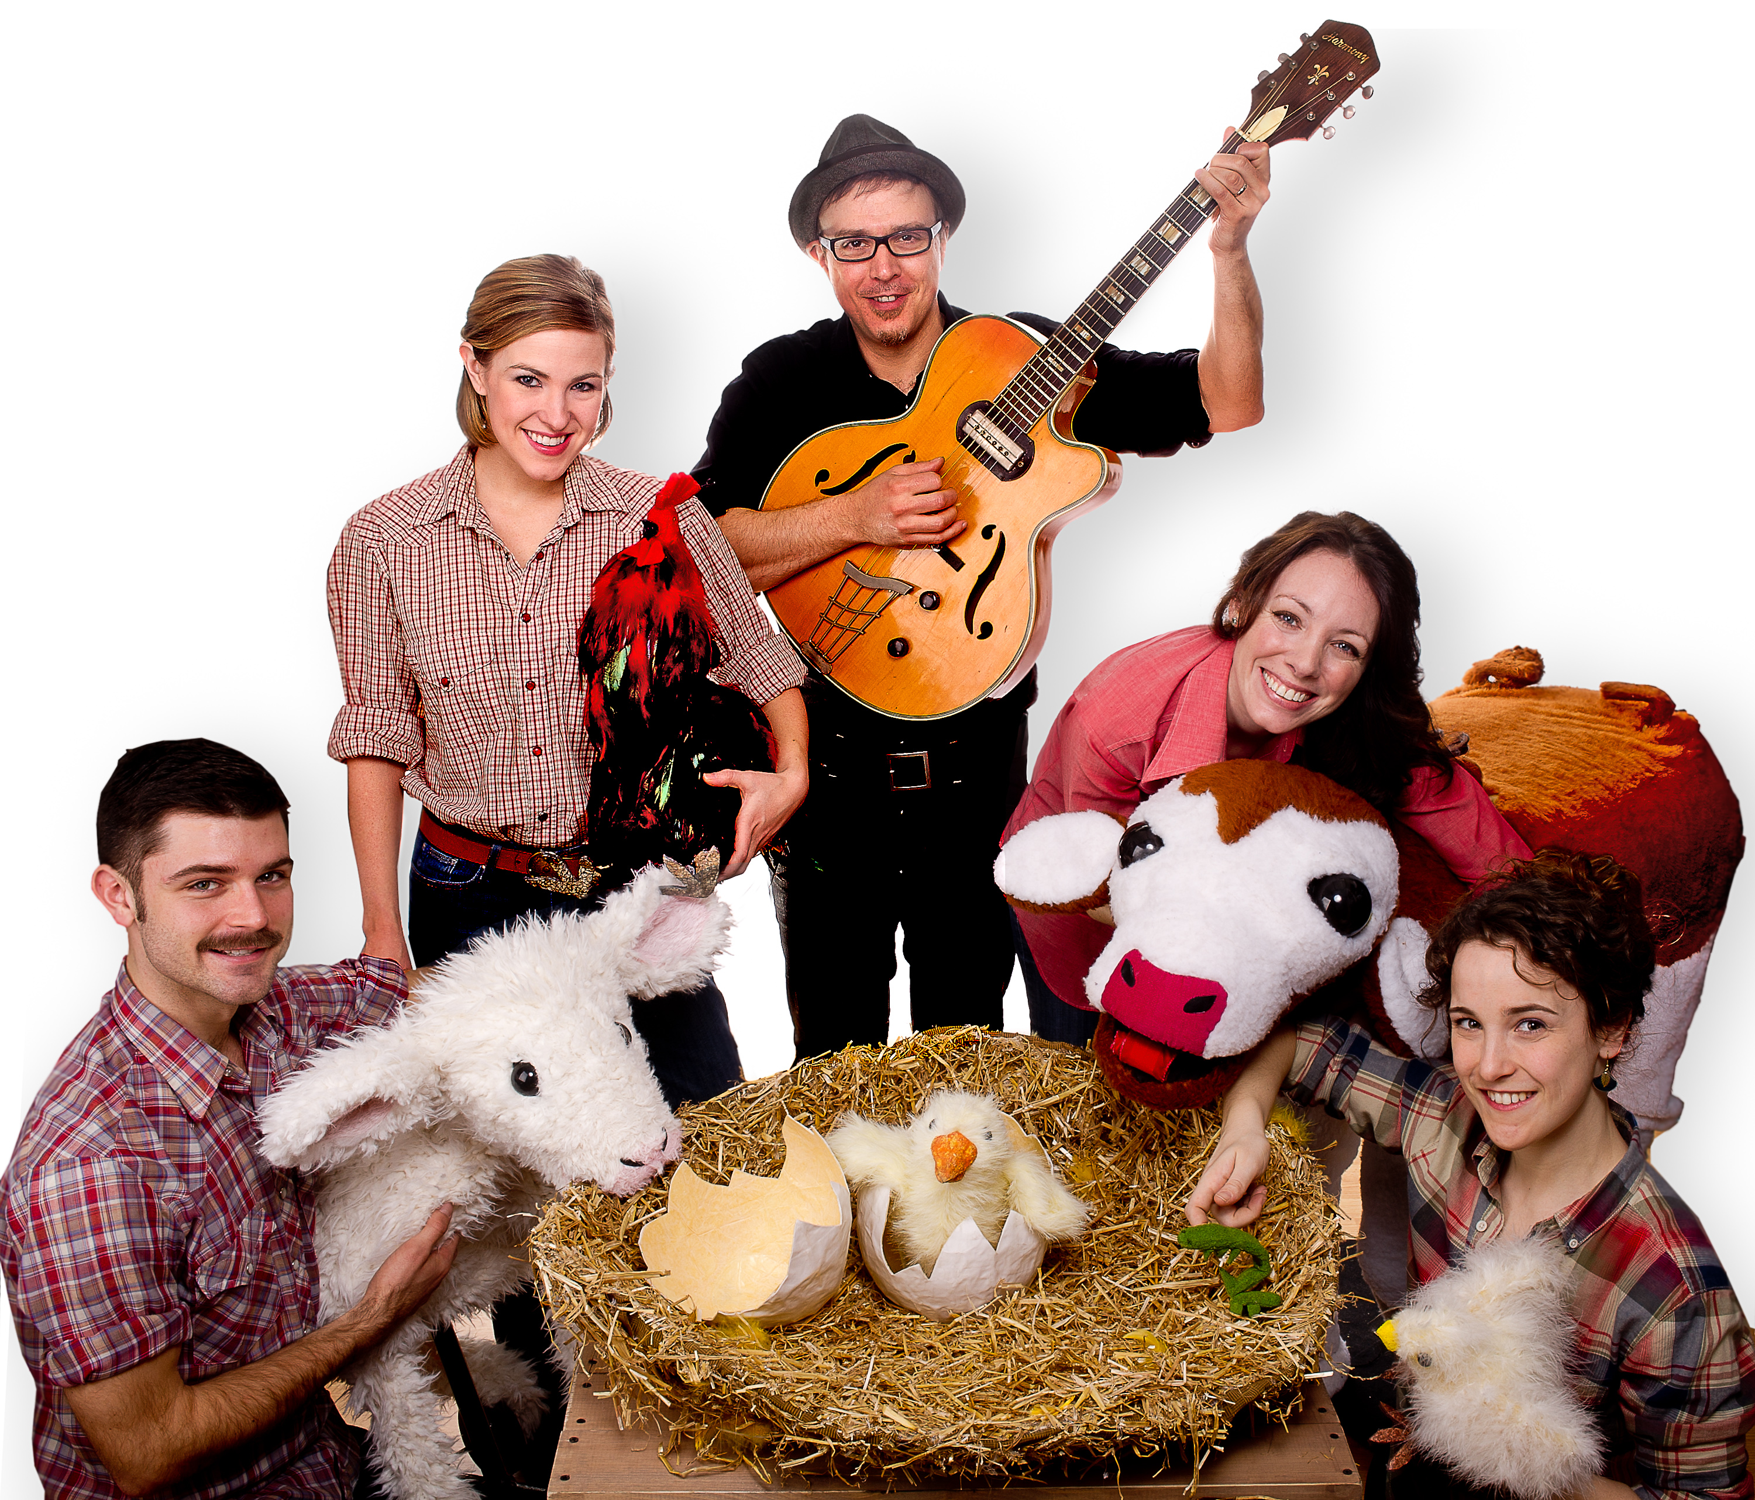

Study Guide

THE PERFORMANCE

Hatched
A Seedling Drama
An Interactive Performance About Life On The Farm
For Babies, Toddlers, Preschoolers and Their Siblings

Told Through Puppets, Live Music, Dance, and Story

Hatched, conceived and directed by Mara McEwin, is the original performance of a newborn chick emerging from her shell at sunrise to a strange and busy world. Told to the youngest of audience members 0-6, it is a first introduction into the theatre, while incorporating both the museum and farm. Performed through movement, handcrafted puppets, and very little human dialogue, the story is set amidst an American family farm. The chick is met by a feisty old rooster, a wobbly calf learning to walk, a gaggle of dancing chicks, a lamb, and a noisy nest of baby birds.

Intimately staged, young audience members are encouraged to interact with the newborn animals as they explore their worlds. Through movement and music, the calf learns to walk, the baby birds attempt to fly, and the lamb makes a new friend with the curious hatched chick. Audience members interact and play with the characters on stage; they give the chicks their feed, milk bottles to the lamb, are licked by the cow, and feed worms to the baby birds. Babies in the audience will be enticed by the animal sounds and textures, while toddlers will love watching and imitating their favorite farm animals as they come to life. Preschoolers will delight in learning about life on the farm and older kids will be entertained by the delightful storytelling, live music and dance. Hatched is a beautiful tale, told through exquisite visuals, music, and the exploration of baby animals on the farm.

BEFORE SEEING THE PERFORMANCE

Ages 1 and Under

  - Introduce farm books
  - Talk about each animal
  - Ask and repeat animal Sounds
  - Point to animal pictures and say the names of each
  - Sing: Old MacDonald Had a Farm, The Farmer in the Dell

Some Great Resource Books:
On the Farm: Bright Baby Touch and Feel by Roger Priddy
Barnyard Dance (Boynton on Board) by Sandra Boyton
My First Farm Board Book by DK Publishing

Ages 2-3
- Toddlers love learning about Life on The Farm
- Introduce different animals who live on the farm
- Have your toddler make the sounds of each animal
- Ask how each animal moves
- Play a dance game: Turn on music and have your child move like a specific farm animal, and then stop the music and have them change animals.
- Farm Animal Yoga: Have your Toddler Stretch like Different Farm Animals.
Poses include; cat/cow (rounding and arching the back on all fours), Downward Dog (lift one leg up and shake it for a wagging tail), Cobra can be a worm, frog jumps, and flapping chicken wings.
Plant a garden with your body: In Child's Pose, you are the seed. Grow tall to standing. Lift one leg to balance in Tree Pose. Pretend to water the Tree Poses, and give sun with a Sun Salutation. Maybe someone could even sit under the Tree's shade!
- Discuss that the Barn and why it is an important place on the farm. This is where the animals live. Ask your toddler where they live.
- Explain where our food comes from. When giving a snack, or a meal, talk about how milk and eggs are made. How fruits and vegetables are grown.
- Plant a seed and watch it grow; what the seed needs to grow
- Sing Old McDonald, The Faremer in the Dell
- Read farm books to your toddler

Some Great Resource Books:
The Farm Book by Jan Floog
Click, Clack, Moo: Cows that Type by Doreen Cronin
Giggle, Giggle, Clack by Doreen Cronin
Big Red Barn by Margaret Wise Brown

Ages 4-5

- Show pictures of different farms
- Talk about the barn, silo, hen house, horse stables, and pig pens
- Talk about the shapes you find on the farm
- Farm animal yoga: Stretch like different farm animals
Poses include; cat/cow (rounding and arching the back on all fours), Downward Dog (lift one leg up and shake it for a wagging tail), Cobra can be a worm, frog jumps, and flapping chicken wings.
Plant a garden with your body: In Child's Pose, you are the seed. Grow tall to standing. Lift one leg to balance in Tree Pose. Pretend to water the Tree Poses, and give sun with a Sun Salutation. Maybe someone could even sit under the Tree's shade!
- Visit a local farm
- Talk about the cycle of food, and what foods come from the farm.
- Plant a seed and watch it grow: Discuss what the plant needs to grow
- What fruits and vegetables can be grown on a farm
- Read books about farm life

Some Great Resource Books:
Farm by Elisha Cooper
The Year at Maple Hill Farm by Martin Provensen
A Busy Day at The Farm By Doreen Cronin
The Farm Alphabet Book by Jane Miller
The Little Red Hen by Paul Galdone
Farming by Gail Gibbons

Ages 6 and Up
- How it is food grown? Discuss food cycles with your class
- Have each child plant a seed and watch it grow in class
- Watch a video on how to milk a cow. Or better yet take your class to the farm and have them watch a cow being milked by hand
- Have your class act out “The Little Red Hen”

Resource Books:
Charlotte’s Web by E.B. White
The Little Rooster and The Diamond Button by Celia Barker Lottridge

AFTER SEEING THE PERFORMANCE

- Who were the characters in Hatched? What sounds did the animals make?
- Talk about what happened in the play.
- What instrument was the musician in the show playing?
- After seeing Hatched, discuss it with your class.
Who was their favorite character and why? Did they notice which actors and dancers played more than one part? How did the actors' and or dancers’ movements and help make the puppets seem real?

SUGGESTED ACTIVITIES

- (Age 3 & up) Have students create their own farm tales. You can have them sit in a circle and each make up a part to the story. It’s okay if the story doesn’t make sense; just encourage students to use their creativity.
- (Ages 6 and up) Have children create their own farm story. They could create this together as a group or as individuals. They could write their stories down, tell the stories out loud, draw their stories or put on a play based on their stories.
- (Ages 2 and up) Act out a story from the farm. You could choose a story like “The Little Red Hen” or the “Song Old Macdonald Had a Farm” The teacher can narrate and choose students to be different characters. You can have many students play the same part if more than one wants to act out a role. This could be a long project or even a ten-minute project. Tell the story to the students and then have them act it out around the classroom.
- (1 and up) Ask your students to imitate the body movements of different farm animals. After they have mastered their animal movements, have them add sounds, or even abstract dance. What happens when two or more of the "animals" meet each other? You can take this exercise further by creating masks to further enhance the animal characters.
- (1 and up) Enjoy food from the farm. Invite students to study different vegetables or fruit that is grown on the farm and make these then into foods for snack time.
- (1 and up) Make a Worm Puppet with your class. You will need: popsicle sticks, green pipeline and glue. Glue or tie the pipeline on both ends of the popsicle stick to attach. For older kids have them glue on googly eyes. Have your class make up a story about a worm. Talk about how worms help food grow from seeds.

For More Puppet Making Ideas, contact us at contactus@treehouseshakers.com

Hatched Residencies and Workshops for Young Seedlings

Ages 2-6
Treehouse Shakers offers several residencies and workshops in conjunction with Hatched, connecting young students to the performance they are about to experience. Students are exposed to movement, storytelling, creative drama, and puppet making. Treehouse Shakers takes pride in tailoring our curriculum to your students’ needs.

Option 1
3-Day Workshops: Students are given one-day introduction workshops (spread out over 3 days) that include; puppet making with household objects, storytelling and creative drama based on world farm animal folktales, and creative movement. Each workshop lasts 45 minutes for 3-6 and tailored specifically with each age in mind. Age 2 workshops last 30 minutes.

Option 2
3-Day Workshops: gearing up to the performance of Hatched that are either in storytelling/creative drama, or creative movement.

Option 3
6, 9, 15, 20-Day Residencies: Students spend 6-20 days (can be once or twice a week) with the teaching artist in creating their own farm animal puppet, creating a farm play of their own, or in creative movement.

Option 4
15-Day Performance Residency: Older students create a dance-play of their own with creative movement, storytelling and puppets. Two teaching artists for each class are provided. 45 minutes.

History
Treehouse Shakers Inc., a not for profit dance and theater company, is committed to creating original dance-plays. Treehouse Shakers was co-founded in 1997 by collaborators and lifetime friends Emily Bunning, Artistic Coordinator/choreographer/
dancer and Mara McEwin, Artistic Director/writer/actor. All of our original dance-plays have been written by McEwin and choreographed by Bunning and embrace the co-founders’ needs to respond, examine and explore societal cultures, perceptions and ideas.

Treehouse Shakers has created and performed eleven original dance-plays for both young and adult audiences in many established performance venues, as well as schools, theaters, festivals and community centers across the nation. Treehouse Shakers’ dance-plays blend dance with a fully realized theatrical script and the multi-disciplinary elements of visual and audio arts. Treehouse Shakers is committed to creating work that encourages people of all ages to experience their feelings and their connection to the greater community. Treehouse Shakers achieves this by experimenting with imaginative parallel narratives, dialogue, spoken word, and exploring the story’s components through the abstractions of modern dance. Treehouse Shakers was named for the wonders of nature, the power of imagination and the excitement of dance. The tree house, like the theater, is a sacred space where imagination is the most potent currency and stories are the roots of the world.

Treehouse Shakers currently has several original dance-plays for young audiences on a rotating tour across the nation including: Animal Rhythms: Two African Folktales, Desert Travels: Tales From the Middle East, Coyote’s Dance: Tales from the American Indian. In April 2009 Let’s Talk About IT!, a piece for teens, joined the repertoire. Animal Rhythms introduces audiences to rhythm, modern dance and theater through the power and culture of West African folklore. Desert Travels gives young audiences a mesmerizing taste of life in the Middle East by portraying the sights, sounds and stories of a remarkable and distinguished culture. Coyote’s Dance follows Coyote, who is both clown and teacher, on a humorous journey of deceit and adventure. Let’s Talk About IT!, Treehouse Shakers’ newest original dance-play, is a coming of age performance exploration, for teens which premiered on tour to Southwest Wyoming in April 2009. Let’s Talk About IT! incorporates the vocabulary of dance, ancient world folklore, real-life stories, and video interviews of everyday teens and pre-teens.

Treehouse Shakers newest Seedling Drama, ages 0-6, Hatched, written and directed by Mara McEwin, is the original performance of a newborn chick who emerges from her shell at sunrise to a strange and busy world. Performed through movement, handcrafted puppets, and very little human dialogue, the story is set amidst an American family farm. The chick is met by a feisty old rooster, a newly born calf learning to walk, a litter of kittens, a baby lamb, and a noisy nest of baby birds. Part touch museum, farm, and a theatrical experience, Hatched is sure to please even the youngest of audience members. Hatched premieres at the Long Island Children’s Museum April 20 & 21, 2012, and May 2012 at The Ailey Citigroup Theater in NYC.

Treehouse Shakers’ work has been praised by Laurel Graeber in the New York Times, and featured in New York Magazine, Time Out Kids, New York 1’s Parenting Report, Fox-5 TV, CBS, Village Voice, The Sun, New York Post, and The Daily News, among others. Bunning and McEwin were interviewed by the online publications’ New York Cool and Small World Productions for their collaborative work. Their young audience work has received funding from the Department of Cultural Affairs, New York State Council on the Arts, The Edith Luytens and Norman Bel Geddes Fund, Nancy Quinn Fund, Lower Manhattan Cultural Community’s Fund for Creative Communities and Manhattan Community Arts Fund, The Puffin Foundation, Ltd., Meet the Composers, BOCES and the Wyoming Arts Council. Some highlighted past venues for all three dance-plays include: United Nations (NYC), The Peter Jay Sharp Theater (NYC), The Ailey Citigroup Theater (NYC), Alden Theater (McLean, VA), Aronoff Center (Cincinnati, OH), Victoria Theatre Association (Dayton, OH), Paramount Theater (Peekskill, NY), Westhampton Beach Playhouse (L.I., NY), Tribeca Film Festival (NYC), Jacob’s Pillow’s Community Day (Becket, MA) and World of Nations’ Festival (Jacksonville, FL).

We would love to hear from you! Send us your drawings from Hatched, or your activities from the study guide. We will to post on our website and blog.
Thank you!!

This study guide was created by the Treehouse Shakers, Inc. © 2012

